Aggregate Economic Loss Simulator
Monte Carlo • VaR & Expected Shortfall • CLT in Risk Management

Problem Statement
In insurance, banking and portfolio risk management the central object is the distribution of the sum of many independent random losses (or returns). Analytic convolution becomes intractable once the number of risks or the size of their support grows. Risk managers therefore rely on Monte Carlo simulation to obtain empirical probabilities, Value-at-Risk (VaR) and Expected Shortfall (ES). We adapt the classic “million dice rolls” idea into a stylized yet fully operational aggregate-loss engine that illustrates exactly these concepts.

Solution Strategy
1. Core pure-Python loop that mirrors the original book (pre-filled dict + progress every second).
2. Two production-style alternates – collections.Counter and a fully vectorized NumPy implementation.
3. Exact theoretical PMF via the classic dynamic-programming recurrence (benchmark for sampling error).
4. Empirical VaR and Expected Shortfall computed directly from the ordered simulated losses.
5. Parameter sweeps that make the Central Limit Theorem visible – the theoretical justification for many regulatory capital formulas.

Solution
Core API: simulate_aggregate_loss, display_results_and_risk_metrics, plot_loss_distribution, simulate_with_counter, simulate_numpy, theoretical_probs, compare_emp_theo, run_risk_sweep.
Classic 2-risk case (100 k scenarios) recovers the familiar 2.8 %–16.5 %–2.8 % shape; empirical VaR₉₅ % = 11 and ES₉₅ % ≈ 11.56. A 5-risk portfolio yields mode ≈ 17, VaR₉₅ % = 24. NumPy is ~24× faster. The 1-to-15-risk sweep shows the rapid approach to normality that underpins large-portfolio approximations.
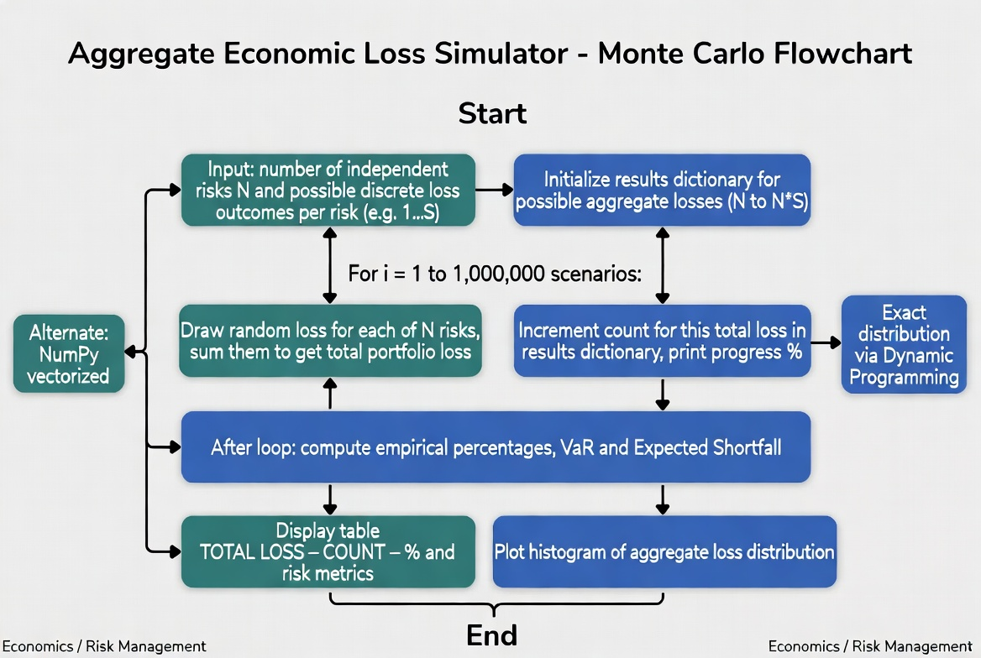
Program flowchart (Monte Carlo path + alternates)
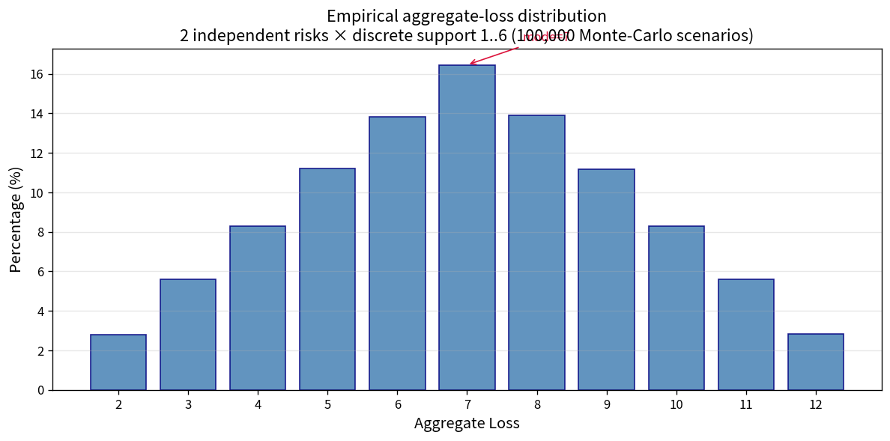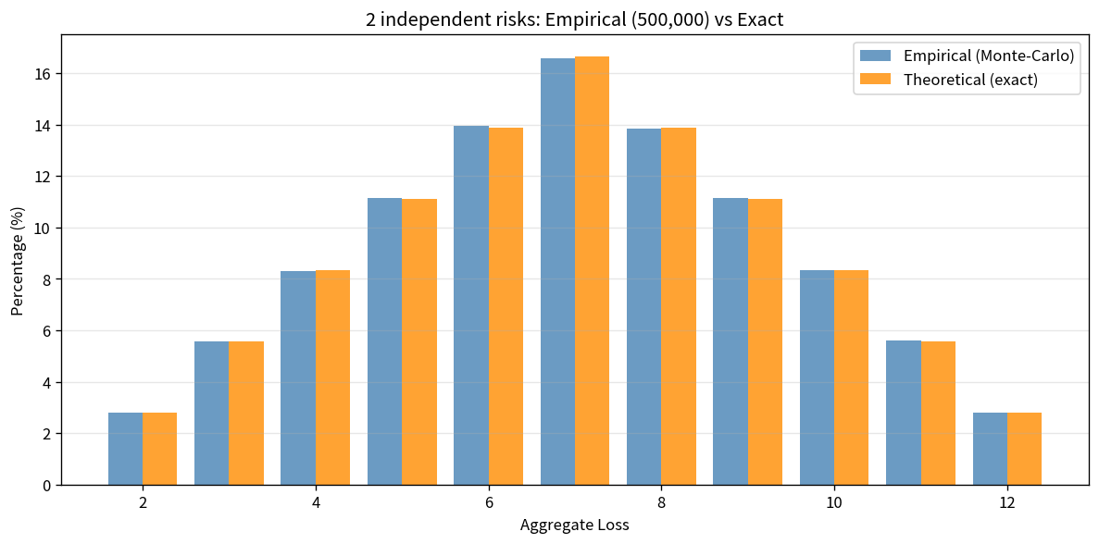
Left: empirical 2-risk histogram | Right: empirical vs exact probabilities
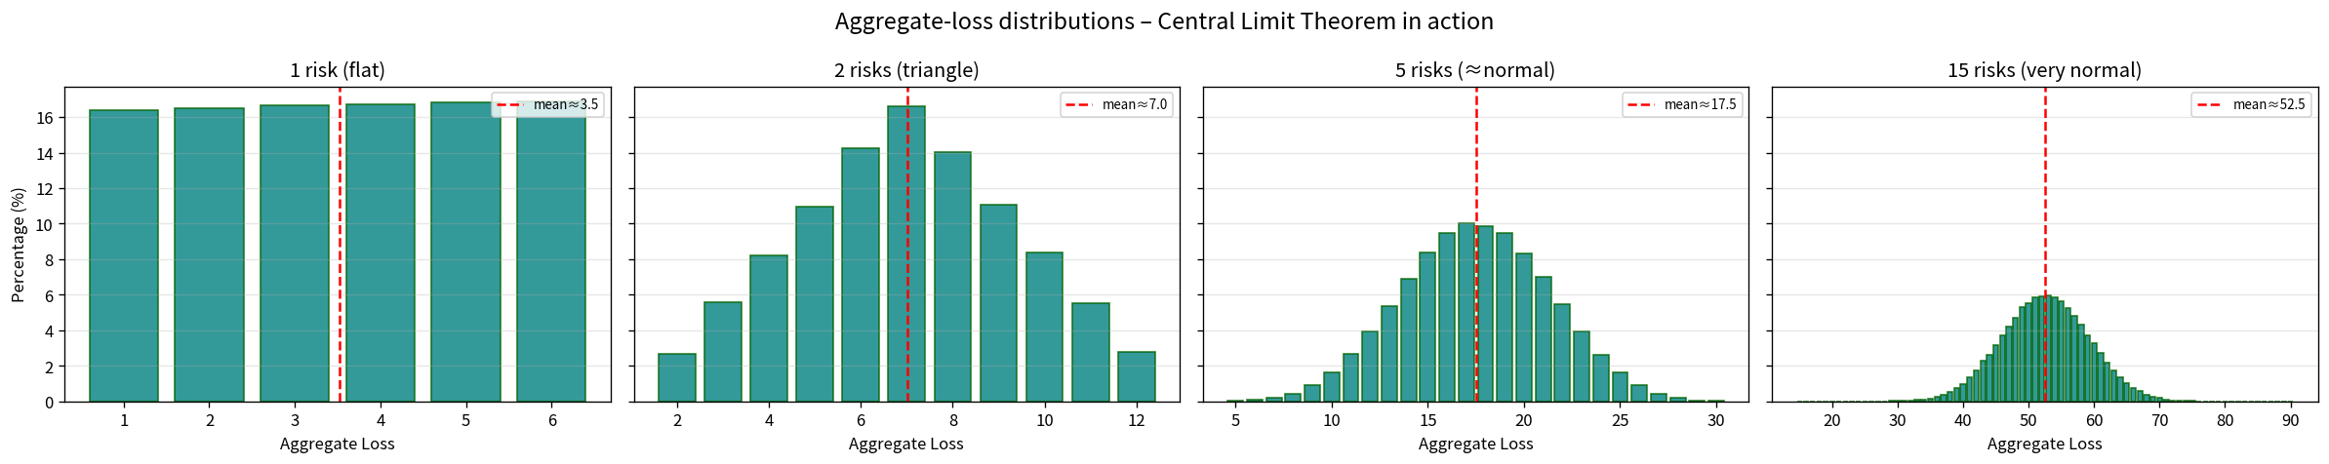
Parameter sweep: 1 → 15 independent risks – Central Limit Theorem in a risk-management setting

Key Takeaways
• Monte Carlo is the practical method of choice for the distribution of aggregate losses when analytic convolution is infeasible.
• Empirical VaR and Expected Shortfall are obtained directly from the ordered simulated scenarios – no parametric assumption required.
• The Central Limit Theorem explains why large portfolios of independent risks can be treated as approximately normal, justifying many regulatory formulas.
• Vectorized (NumPy) implementations turn a pedagogical loop into production-speed code while preserving identical statistical meaning.
• Always benchmark Monte-Carlo results against an exact DP solution for small portfolios; the discrepancy quantifies sampling error.
Deliverables: Practice_Skeleton.ipynb • Solution.ipynb • flowchart & analysis PNGs • this 1-page report.

